Govt. High School
Sindhi Jamaat Co-Operative Housing Society, Karachi
Final Term Examination 2024-25
Subject: G. K | Class: One | Total Marks: 50
Name: ___________________ |  | Sign: ____________________
GR No: ___________________ | Date: ____________ | Obtained Marks: _________

Q1: Fill in the Blanks: (10)
- I __________ with my nose.
- I have __________ hands.
- I __________ with my tongue.
- We keep __________ shorts.
- We __________ our teeth every day.
- We take __________ every day.
- Ali and sana __________ in the morning.
- They wear __________ uniform.
- We __________ our hands before and after eating.
10- I see with my __________.

Q2- Write meaning of the following words. (10)
Words | Meaning
See
Hear
Smell
Clean
Healthy
Wash
Get Up
Wear
Pary
Give

Q3: Write Answers of the following Questions: (10)
Q1: What do you see in the sky at night?
A:
Q2: How do you do with your nose?
A:
Q3: How many times do you clean your teeth in a day?
A:
Q4: How do we keep ourselves clean?
A:
Q5: What do you see in the sky at day?
A:

Q4: Label the Parts of Body: (10)
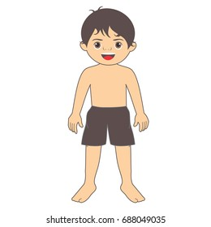


Q5: Write True or False. (5)

I get up in the morning.
I Greet my Parents.
I do not put litter in the bin.
I smell with my eyes.
I taste with my hands.

Q7: Math the following body parts with following pictures. (5)
Body Parts | Things
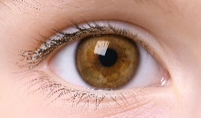 | 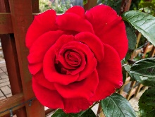
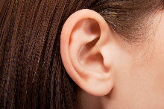 | 
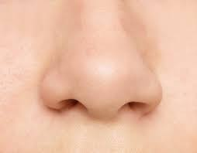 | 
 | 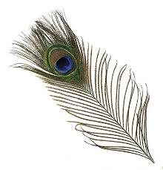
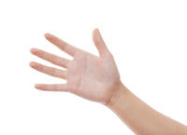 | 